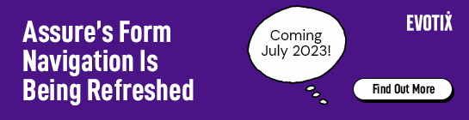
Communicating the upcoming refresh of Assure’s Form Navigation to your team
As we’ve previously communicated, the Form Navigation in Assure is getting a refresh in July. To help communicate the changes to your internal teams, we have drafted an email for you to customise and share with your team. You can find the email on the next page. Please copy and use as you see fit.
We hope you and your teams find the updates as exciting as we do! Don’t forget that the existing functionality is not changing.
Thank you and stay safe,
Your Evotix Team

Email Template:
For your managers, colleagues and leadership team that have access to Assure to manage safety activities
Please review and customise as needed

Subject: Changes Coming to Our Safety Management Tool Assure on 10 July
Dear colleagues,
We are communicating with you today to make you aware of an update to the way you fill in a form Assure, the safety management tool that we use to report and manage all our safety activities. The design update will roll out on 10 July.
What is changing?
The overall functionality of the form and records is not changing.
However, when you access Assure after the update, you will see that the way you navigate through a form has changed. These are the changes you should see.
- A new side navigation bar replaces the current tabs at the top. Use this to navigate through all the sections of a form.
- The options on the bottom bar are being updated to only include the key options you need to progress through a form.
- All supporting items are available from the side navigation bar making it easier to access all information linked to the record in one place. Supporting items include actions, attachments, notes, signatures, policy/guidance, reviews, and approvals.
This video will take you through the changes and how to navigate through forms after the update.
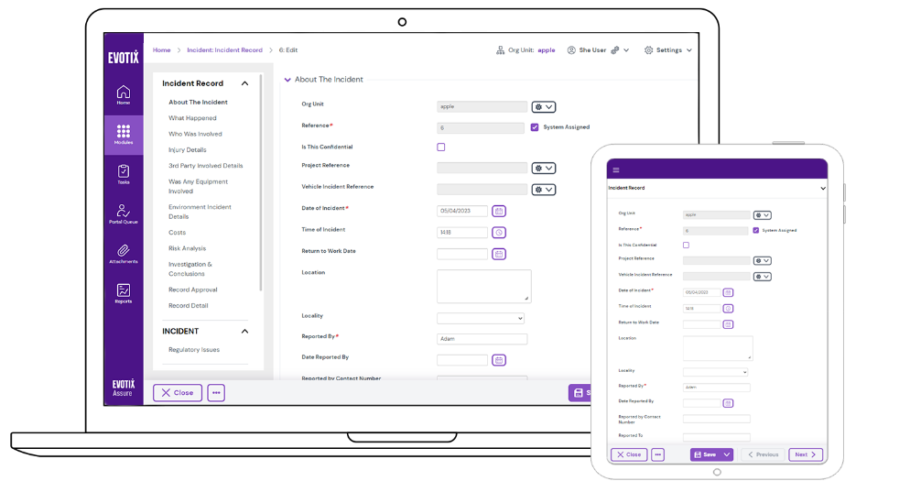
What do I need to do?
Take some time to watch this video which will take you through the changes and how to navigate through forms after the update.
After the release on 10 July the changes will automatically be seen. You don’t have to do anything. When you first log in, familiarise yourself with the new navigation and how to access form.
We will also be working on updating our existing training material and documentation in due course for new starters.

How do I access Assure?
As is the case today, you can access Assure via this URL link (Please add your link) You should be aware of your username and password.
If you have any issues accessing Assure at any point, please contact: Add details

Regards and stay safe
NAME

