**Communicating the upcoming design refresh of Assure to your team**

As we’ve previously communicated, the user interfaces (UI) of Assure and AssureGO+ are getting a makeover on 13 September. To help communicate the changes to your internal teams, we have drafted two email templates for you to customize and send. Please use as you see fit.

* Email 1: For your colleagues that use the mobile app, AssureGO+, to report or access documents
* Email 2: For managers using Assure to manage any safety activities

We hope you and your teams find the updates of Assure and AssureGO+ as exciting as we do! Don’t forget that the existing functionality is not changing.

Please reach out to your Customer Success Manager or our support team if you have any questions.

Thank you and stay safe,

Your Evotix Team

**Email 1:**   
**For your colleagues that use the mobile app, AssureGO+, to report any safety activities or access safety documents**

*Please review and customize as needed*

**Subject:** Changes Coming to Our Safety App AssureGO+ on Tuesday, 13 September

Dear colleagues,

We are communicating with you today to alert you of an update AssureGO+, the mobile app we use to report all of our safety activities. The design update will roll out on Tuesday, 13 September.

**What is changing?**

Mobile reporting and how you access information will not change. The changes will mostly be design elements which include:

* New colour themes (currently blue): While you might see the default purple colour, it will adjust to our brand colours shortly after go-live.
* Refreshed illustrations on loading screens.

[This short video](https://evotix.wistia.com/medias/9em3niqw1k) will take you through the changes.

**What does it mean for me?**

You don’t have to do anything. When you log in after 13 September you will experience the new UI. Access to forms and documents will remain the same.

**How do I access the safety app?**

As is the case today, you can access the app via this URL (PLEASE INCLUDE YOUR URL) on your computer, mobile or tablet.

Please use this app to make the team aware of any hazards you spot, near misses, to report incidents or complete inspections. We monitor anything reported on a daily basis so we can act quickly and support you.

If you have any issues accessing or using the app, please contact: Add details

Regards and stay safe

YOUR NAME

**Email 2:**

**For your managers, colleagues and leadership team that have access to Assure to manage safety activities**

*Please review and customize as needed*

**Subject**: Changes Coming to Our Safety Management Tool Assure on 13 September

Dear colleagues,

We are communicating with you today to alert you of an update to Assure and AssureGO+, the safety management tools that we use to report and manage all of our safety activities. The design update will roll out on 13 September.

**What is changing?**

Existing functionality and how you report and review safety events, manage actions or review dashboards and reports is not changing.

However, when you first access Assure after 13 September, you will see the following design changes which means Assure navigation will change:

1. **New colours** – these may change over time as we make adjustments to reflect our colours
2. **New navigation bar** at the side (for desktop) or the top of the screen (for smaller screens) – to access all module records
3. **Homepage redesigned** – ‘Shortcuts’ and ‘Quick add records’ are available without scrolling
4. **Updated layout of record overview**– with workflow steps more intuitively accessible accessible from the overview cards
5. **AssureGO+** will be refreshed with colours aligned to Assure and updated illustrations on loading screens. There is no change to the layout and how to access forms.

[This short video](https://evotix.wistia.com/medias/34fqxfo4u1) will take you through the changes and how to navigate with the new navigation bar.

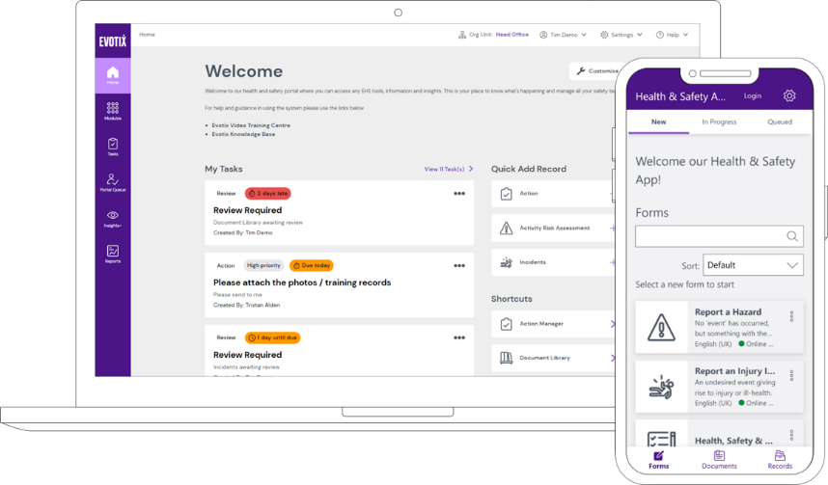

**What do I need to do?**

*Before 13 September*

Take some time to watch the video and review the additional documentation so you are familiar with the changes. Save this communication so you can easily refer to it once the changes have taken place.

*On or after 13 September*

Once you log in on, or after, 13 September, you don’t have to do anything. The changes will automatically happen.

Some things you may want to do when you first log in:

* Familiarise yourself with the navigation and how to access your key information
* Review your quick links and shortcuts and customize those if you haven’t already

Over time you may notice some changes to the colour theme. This is totally normal and does not change any of the app’s functionality.

We will be also be working on updating our existing training material and documentation in due course for new starters.

**How do I access Assure?**

As is the case today, you can access Assure via this URL link (Please add your link) You should be aware of your username and password.

If you have any issues accessing or using the app at any point please contact: Add details

Regards and stay safe

NAME